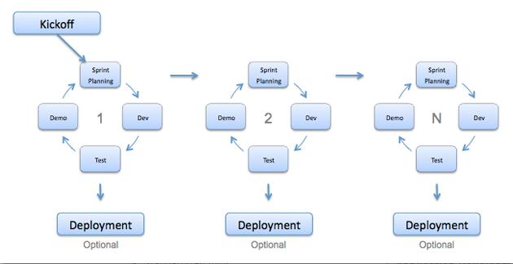

The researchers used the agile model in building the web site because this methodology is more flexible than traditional modeling methods, making it a better fit in a fast changing environment. Agile assumes that the end user’s needs are ever changing in a dynamic business and IT world. Changes can be discussed and features can be newly effected o removed based on feedback. This effectively gives the customer the finished system they want or need. Having options gives them the ability to leave important decisions until more or better data or even entire hosting programs are available; meaning the project can continue to move forward without fear of reaching a sudden standstill. The researcher used the method because of its capabilities.